Nozomi 19.0.5 Patch Validation

Test‐1: Added a new HMI/Laptop (IP – 192.168.100.11) onto the network.
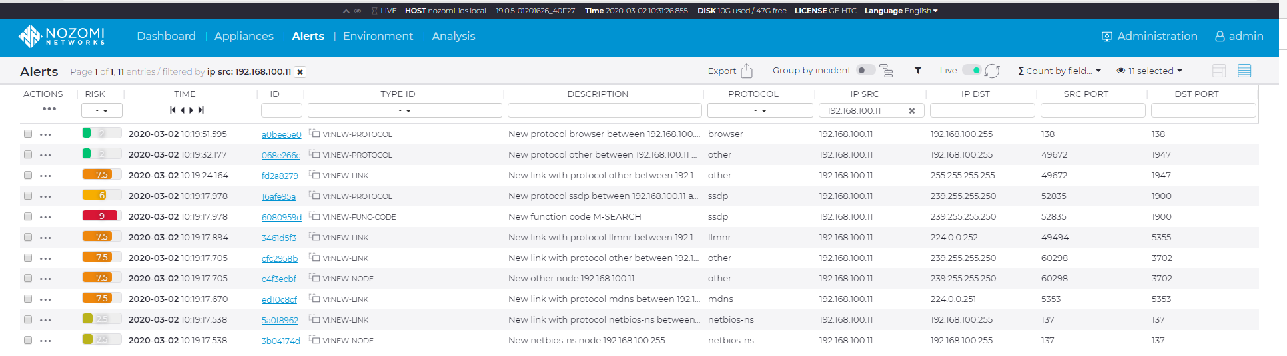

Nozomi alerts this as a New Link on the network. A syslog message is also generated and forwarded to the Graylog server:

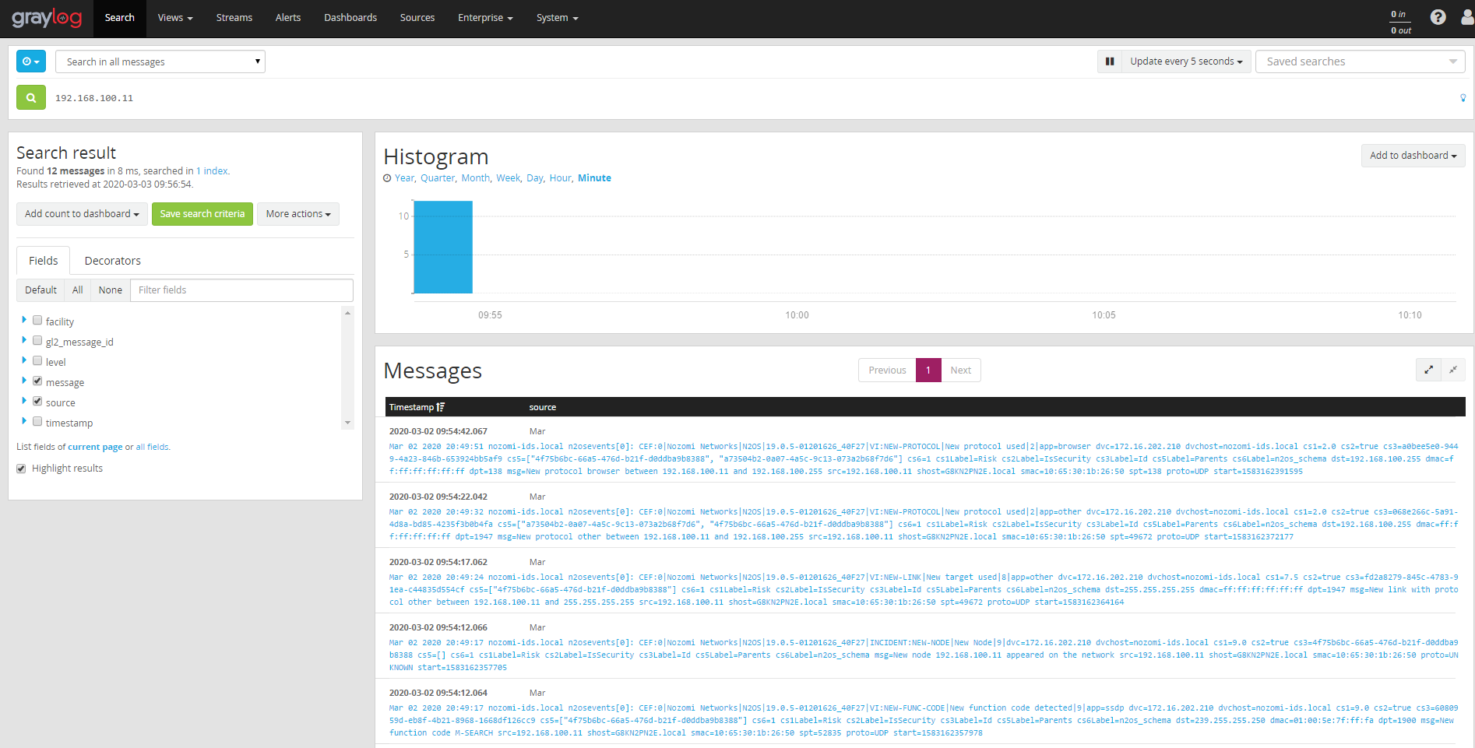

Test‐3: User on Test HMI (IP – 172.16.101.54) makes a change in controller code and performs a build & download to the Controller (IP – 172.16.101.32)

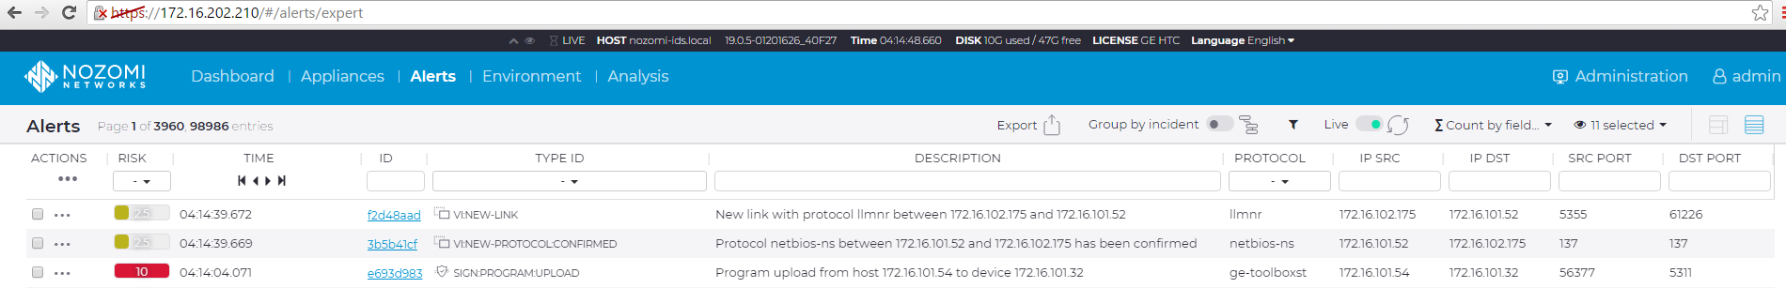

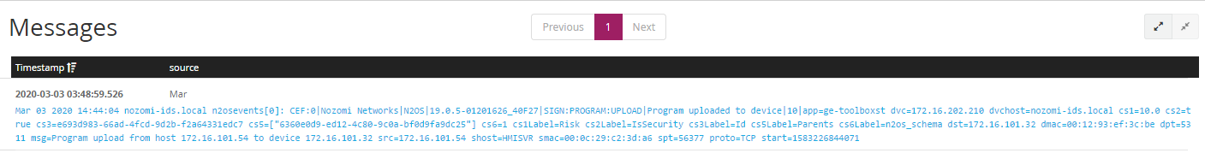

Previous Observations/Summary:

• Every new device that was added to the network was clearly identified and alerted by Nozomi.
• DHCP traffic that is generated when an HMI/VM connects on to the network is not recorded by
Nozomi.
• Nozomi generates an Alert only first time a user connects to the Mark‐Vie Controller
• No alerts are generated when user tries to force a value from TCW file
• Nozomi generates an alert with Risk rating of 10 when a user alters the Controller code and downloads
the code to controller if the controller is in Open State
• However, if the controller is on Secure State, a user altering the Controller code and downloading the
code to controller is not alerted.
• Unless proper zoning and filtering is performed on Nozomi devices, duplicate alerts are being generated by Nozomi devices and CMC does not reconcile these duplicate alerts

Current Observations/Summary:
Same as Previous. Last Point not yet tested.

Network Scan/Malicious Operations
Test‐1 Ping Scan: Command executed in Nmap: nmap ‐sn 172.16.192.0/20.
Nmap ping scans are not detected by Nozomi.

Test‐2 Quick Scan: Command executed in Nmap: nmap ‐T4 ‐F 172.16.192.0/20. In the following screenshots we can see that there are alerts were generated on Nozomi when Quick scan was executed.
Nmap quick scan was detected & alerted by every Nozomi device.
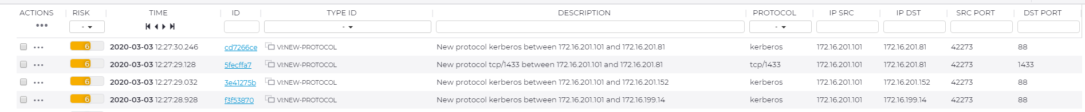

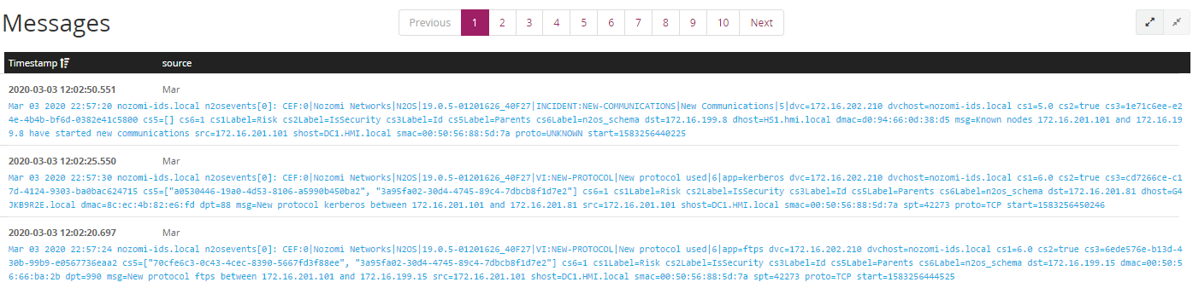

Test‐3 Regular Scan: Command executed in Nmap: nmap 172.16.192.0/20. In the following screenshots we can see that there are alerts were generated on Nozomi when Regular scan was executed.

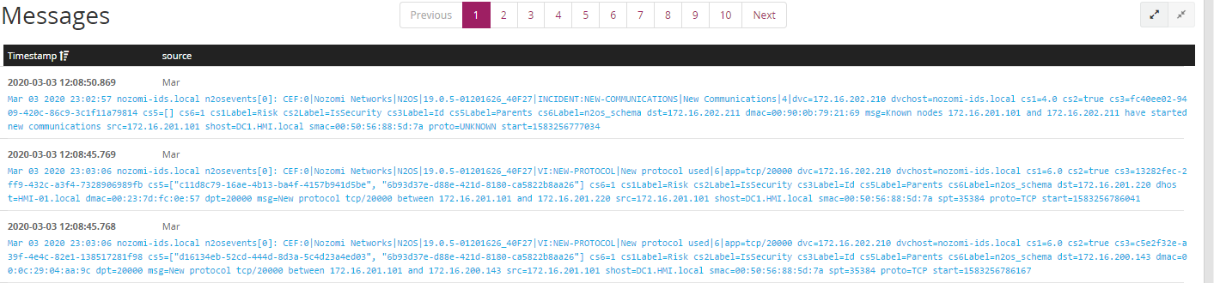

Test‐4 Intense Scan:

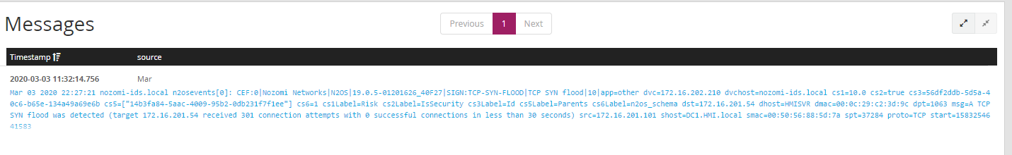
Test‐5 Christmas Tree Scan: The Christmas tree scan was performed using nmap command.

With existing rules in Nozomi Christmas tree scan was not detected and not alerted. Although with a a2qcustom rule in place we were able to detect the attack. Nozomi development team is currently looking into the rule for detecting the Christmas tree attack using nmap.

Test‐6 Tear Drop Test: The Tear Drop Test was performed from test device (IP – 172.16.200.140) to a host (IP – 172.16.201.101).

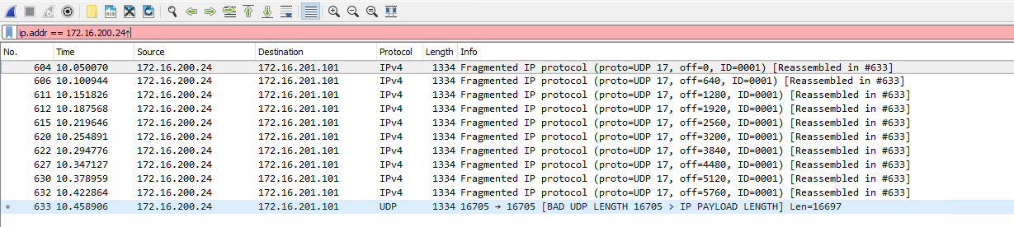
Wireshark capture on the Host identified the fragmented packets. However, Nozomi did not detect the Tear Drop attack.
Test‐7 Large File Transfer: Test computer (IP – 172.16.200.3) tries to copy a 1.5 GB file to host (IP – 172.16.201.200)
over the PDH network.
When a file transfer is initiated between two nodes, the protocol used (SMB) is flagged as an alert. The file size has no bearing on the alert being generated. Also, this alert gets generated only when the two nodes are using that protocol for communication for the first time. Subsequent connections using the same protocol between the links are not flagged. Alerts are being forwarded to Graylog.

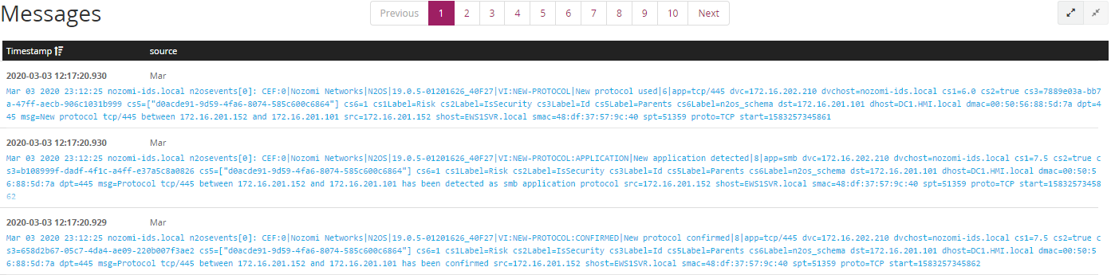

Test‐8, 9, 10: SSH,FTP,RDP protocols

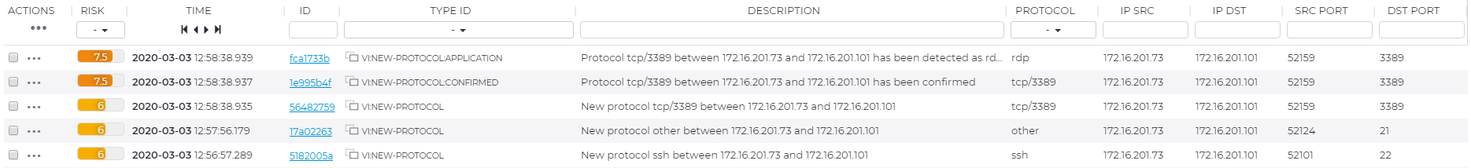

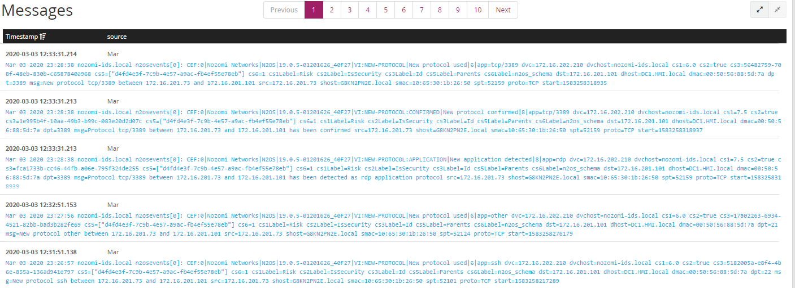

Previous Observations/Summary:
• Network scanning attempts – Ping Scan, Christmas tree and TearDrop attacks were not detected by
Nozomi
• Nozomi detected intense scan, quick scan and regular scan attempts from Nmap application when
scanning the PDH subnet.
• New SSH, RDP, FTP connection attempts between two devices internal to the control system network
was detected and alerted by Nozomi
• A large file transfer attempt between two devices was detected and alerted. There is no rule by
default to alert the user about the size of the file that is getting transferred. Any new protocol seen
by Nozomi between two nodes will generate an alert. Subsequent connections with same protocol
do not generate an alert.
• MODBUS & IEC‐104 communication between two devices was detected and alerted by Nozomi.
• MODBUS & IEC‐104 communication alerts might overwhelm the user as an alert will be generated
for every action. In a typical implementation of MODBUS & IEC‐104 communication Master & Slave
are in continuous communication with each other, this would result in continuous alerts/messages
being generated by Nozomi.

Current Observations/Summary:
Same as Previous except last two points, not yet tested.

8 External Communications
In this section, an external device tries to make connection with the control system asset using SSH/FTP/RDP.

Test‐1 SSH-RDP-FTP Communication: Test HMI (IP – 192.168.201.10) tries to perform SSH connection to a control system HMI (IP – 172.16.201.200).

This connection attempt was captured and alerted by Nozomi. A syslog message was also sent to Graylog server.

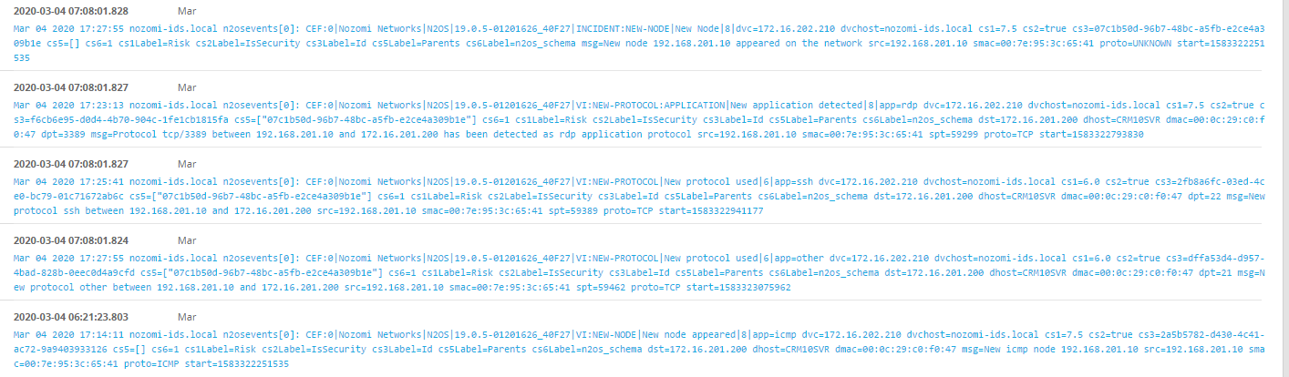

Previous Observations/Summary:
• Nozomi generates an Alert when first time an external device makes a new connection with the control system device.
• For FTP connection, the protocol was shown as “Other” which will be difficult for customer to uniquely
Identify.

Current Observations/Summary:
Same as Previous.

Extra Observation:
The control server is now currently detected as web-server.

